Purpose of this document

This document is an element of the HPRO Equity, Diversity and Inclusion (EDI) Assessment Toolkit.
Within the toolkit, the EDI Organizational Assessment and Action Guide document provides resources and tools for Regulatory Colleges to use in assessing the current state and identifying opportunities for making progress in their own EDI efforts. The tools are not meant to be prescriptive. Each College will have its own way to approach the process.
These Case Studies are designed to help College staff, Council and committee members, and interested others to understand how the tools might be effectively applied. These case studies are fictional. It is hoped that as Colleges gain experience with the tools, they will document their experience in new case studies to support broad knowledge-sharing within the HPRO networks.

Case study 1: A focused start to an ‘Equity Impact Assessment’ of Registration
The College in numbers | - College ABC has approximately 3 000 registrants and 5 staff.  - Registrant numbers have been increasing steadily over the last ten years, and new registrants now account for about 10% of their total numbers.  - About two-thirds of their registrants identify as men; and two-thirds are under 40 years of age; approximately 8% were educated outside Ontario and 3% outside of Canada.
The EDI context | - The Council has had discussions about the need to review registration practices for racial equity, particularly in light of increasing interest in registration in the profession and apparent increase in diversity of new entrants. They are confident in the entry-to-practice exam but have discussed that any potential impact of the recent introduction of an online exam administration should be reviewed.  - One current EDI issue is: The professional association has devoted considerable attention on outreach to postsecondary students, including international students. The association has approached members of the Council to express concern about the equity of the registration process for newcomers to Canada – whether trained in Ontario or elsewhere.
Scoping the review | - Council asked the College staff to undertake a pilot Equity Impact Assessment focused in one area. Staff were asked to confirm a priority focus and suggest an approach.  - Staff used the Self-Assessment Grid to do a high-level review of the current status within the College.  - They identified Domain #6, Suitability to Practice, as an appropriate area of focus, with a particular emphasis on Registration. They estimate that that the College’s current practices might reflect the Reactive level and that there would be interest in making progress to the Proactive level.  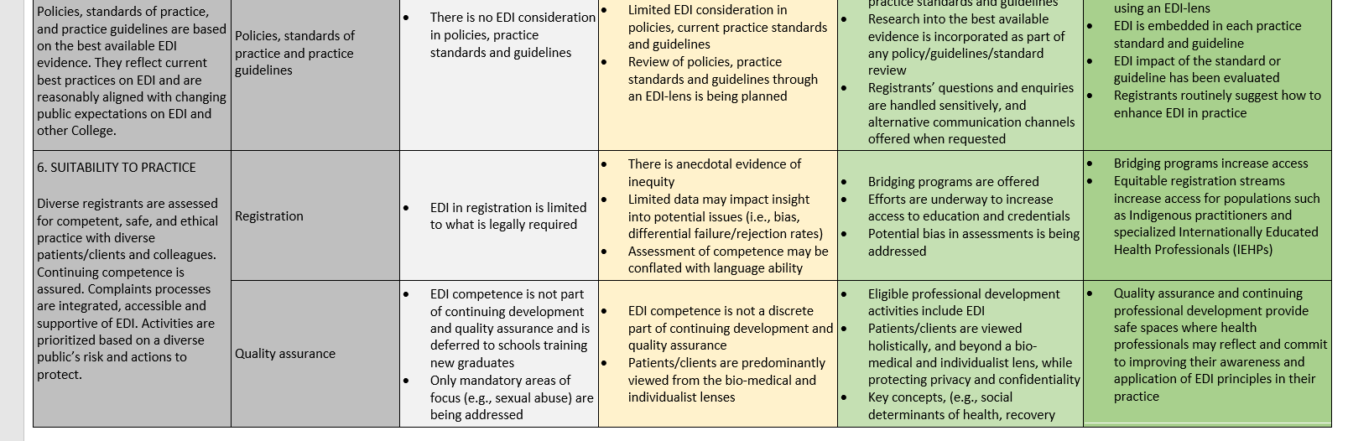  - Staff used the scoping tools in the Guidance Document (HPRO Equity Impact Assessment in Domains 5 and 6) to discuss an appropriate approach with the Council. Given their capacity and other strategic priorities, a focused and light touch approach was selected as an appropriate first step. They agreed upon the following course of action:  - Strike a working group composed of two staff members, two members of the Registration Committee, and one member of the Examination Appeals Committee.  - Use the Assessment Markers to do a more detailed review of the College’s equity status in Domain #6.  - Report back to Council in three months, with initial findings and suggested next steps.
Assessment | - The working group focused on the Assessment Markers for Registration, within Domain #6, Suitability to Practice. They decided to do independent ratings of the items in all four levels (Proactive to Progressive) and then meet to discuss and produce a consensus rating for each item. They recognized that they were missing some information but could generally agree on clear strengths and clear gaps or missed opportunities.  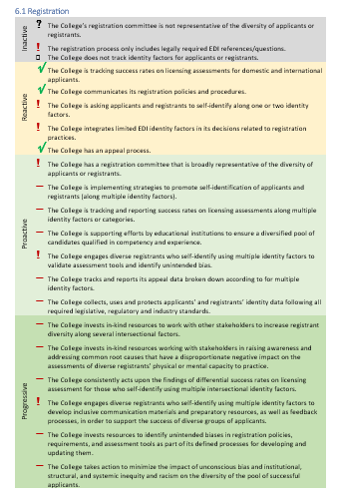  - In discussion with the Council, there was a strong concern about the lack of explicit representation of equity-seeking groups within the assessment process, particularly in the absence of meaningful equity data about applicants and registrants. It was agreed that next steps would be to consult more widely.
Consultation and decisions for action | - Using tools in the Guidance Document (HPRO Equity Impact Assessment in Domains 5 and 6), the working group created a three-month consultation plan and sought input from stakeholders and members of equity-seeking groups of applicants and registrants.  - The working group presented the findings and recommendations to the Council.  - An action plan was developed and approved.
Follow-up | - The action plan was funded and completed over the following year, leading to enhanced data collection and a more inclusive process for revision to the entry-to-practice exam.  - Results and ongoing commitments were reported directly to the professional association and posted on the College’s website. The process and outcomes were included in the following year’s CPMF report.

Case study 2: Applying an Equity Lens to the College’s Practices
The College in numbers | - College JKL has approximately 14 000 registrants and 28 staff.  - About 60% of registrants are under 50 years of age. About 65% identify as men, with significantly more men in the older age brackets. About 40% were initially trained outside Ontario; about 30% outside Canada/USA.
The EDI context | - The College is in the process of creating its new strategic plan. An enhanced focus on Equity, Diversity and Inclusion (EDI) will be highlighted. The Council wants to undertake a broad-based review of the College’s practices in order to define three areas for EDI action within the upcoming three-year period covered by the plan.  - The College has previously undertaken initiatives to examine fairness in registration practices, specifically related to internationally educated applicants. It has recently hired a senior professional staff member to focus on broader aspects of EDI.  - There have been recent initiatives to collect diversity-related data from current registrants. Despite a limited response rate, the results clearly demonstrate that diversity is increasing among more recent registrants.  - Pressures have been mounting from stakeholders, educational institutions, and the public to demonstrate equity and responsiveness in the College’s practices.
Scoping a review | - Council asked the College staff to collaborate with the Strategic Planning Committee in conducting an equity-focused review of the College’s practices aligned to the CPMF reporting domains. The College has committed to consultation and engagement in the development of the strategic plan; the definition of the EDI component must reflect this.  - Given the importance of the upcoming strategic plan, the timeframe was set at six months.  - Staff and two members of the Strategic Planning Committee used the tools in the Guidance Document (HPRO Domains 5 and 6) to clarify the scope and agree on an engagement process.  - A broadly representative EDI Planning Task Force was created. The EDI staff professional adapted the HPRO Equity Impact Assessment Overview presentation slide deck to brief the task force members on the HPRO initiative’s background, purpose and available tools and resources. A key element was to create a working definition of equity, diversity and inclusion that would build on, yet go beyond, their previous focus on gender and internationally educated professionals.  - As a step to familiarize themselves with the materials, the group reviewed the Self-Assessment Grid and agreed that all of the domains were relevant for their work. They agreed on a process for using the more detailed Assessment Markers for a broad review of the status of the College’s practices.
Assessment | The task force divided the domains among a number of small working groups, who used the Assessment Markers to evaluate and document the status of the College’s current EDI-related practices.  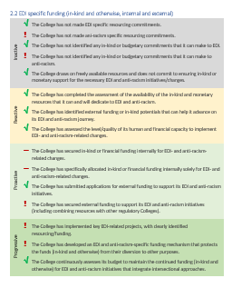  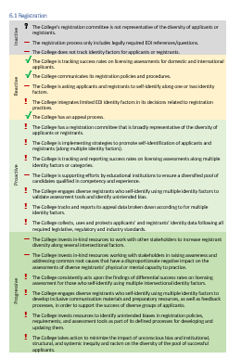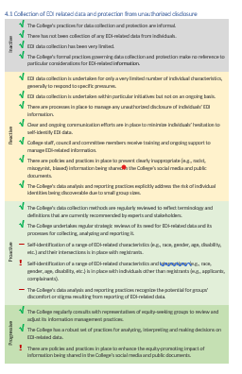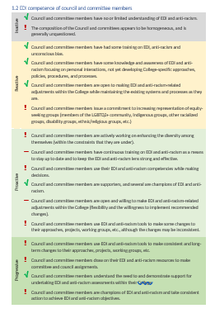  - In two working sessions, the task force reviewed the outputs of the working groups and came to a consensus rating for each domain.  - The task force members acknowledged that the assessment was not an ‘exact science’ but they agreed they were very confident that their process had generated a reasonable basis for identifying the College’s strengths and gaps, and related priorities for the strategic plan.
Consultation and Decisions for Action | 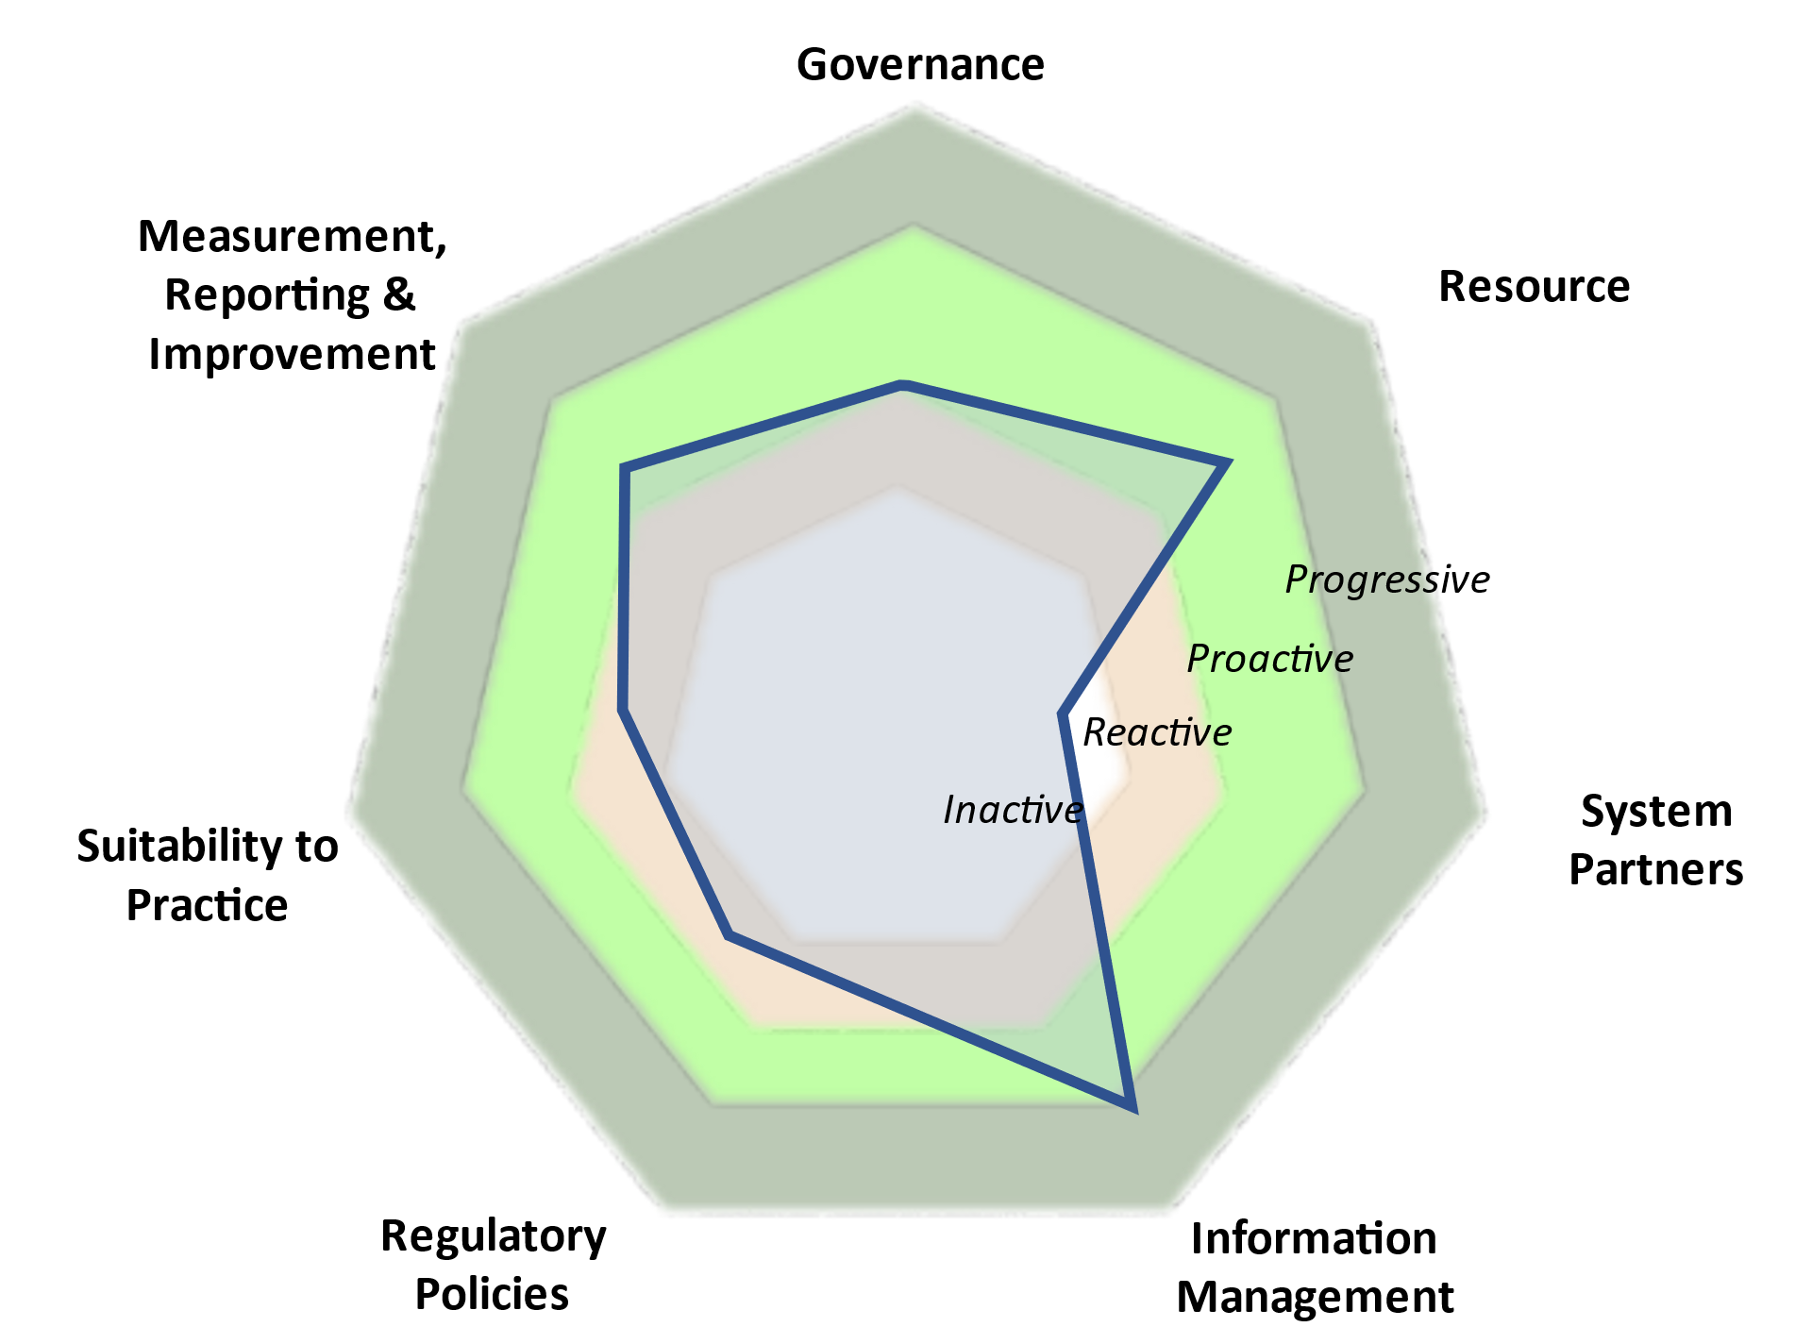  - To validate the conclusions, the task force members used tools in the Guidance Document (HPRO Equity Impact Assessment in Domains 5 and 6), and the FAQs to identify and consult with people in their networks, key stakeholders, and representatives of equity-seeking groups.  - The Strategic Planning Committee concurred with the task force’s findings. They recommended that the three-year strategic plan should focus on selected EDI matters with respect to System Partners, Regulatory Policies and Suitability to Practice.  - The Council approved the recommendation. The Strategic Planning Committee used the details from the assessment process to expand upon the EDI section in the strategic plan.
Follow-up | - The strategic plan’s EDI section was further developed with timeframes, desired outcomes, budget, and a consultation and engagement process.  - Progress was reported on an ongoing basis throughout the plan period, in stakeholder engagements, public communications, and CPMF reports.

Case study template: Learning from experience

As Colleges start to use the EDI Organizational Assessment and Guidance Document it is expected that their experiences will generate useful insights to share. To support knowledge sharing, the template below can be used by Colleges to capture and share their experiences when applying the tools to their own practices.

The College in numbers
The EDI context
Scoping a review
Assessment
Consultation and Decisions for Action
Follow-up

